**PROJECT STATUS**

**Problem Statement:**

Gender Recognition system from audio files using FFT with Artificial Neural Networks.

**Status:**

**9. New Predictions with user interface**

**The Modules used:**

import math

import pandas as pd

import numpy as np

import sys,os

from colorama import init

from termcolor import cprint

import termcolor

from pyfiglet import figlet_format

import keras

import h5py

from keras.models import Sequential

from keras.models import load_model

from keras.layers import Dense

from sklearn.preprocessing import StandardScaler

The main interface file actually uses exceptional handeling to install the dependencies if it is not installed.

**Script:**

if __name__ == '__main__':

try:

os.system("pip3 install -r requirements.txt")

os.system("reset")

except exception as e:

print("there is a missing package .\n Error Occured :{}".format(str(e)))

**Predicton:**

#infinte loop for infinite prediction

while True:

#asking for input

prCyan("\n\nThere are list of extracted values from ranges 0 - 3167 audio files consist of 12 fetures")

print("\n\nPlease select from the above extracted data usng serial number as 0 - 3167 \n")

prRed("Please enter the number:")

#taking input values

resp = int(input())

#displaying response feature

print(dataset.iloc[:,:-1].values[resp])

#loadng classifier

classifier = load_model("classifier/clf.h5py")

#scaler

scaler = StandardScaler()

datas = (dataset.iloc[:,:-1].values[resp].reshape(-1,1).T)

#predicting data

res = (classifier.predict(datas))

#printing value

print(res)

#making descision

if res > 4.3*10**-6 :

print("Predicted Gender is : {}".format("Female"))

else:

print("Predicted Gender is : Male")

#printing the actual label

print("The actual gender is : {}".format(dataset.iloc[:, -1].values[resp]))

We have actually trained the classifier , now we can use the pre trained classifier to predict new outcomes with simple terminal based interface which also inclued ascii art.

**Main Interface:**

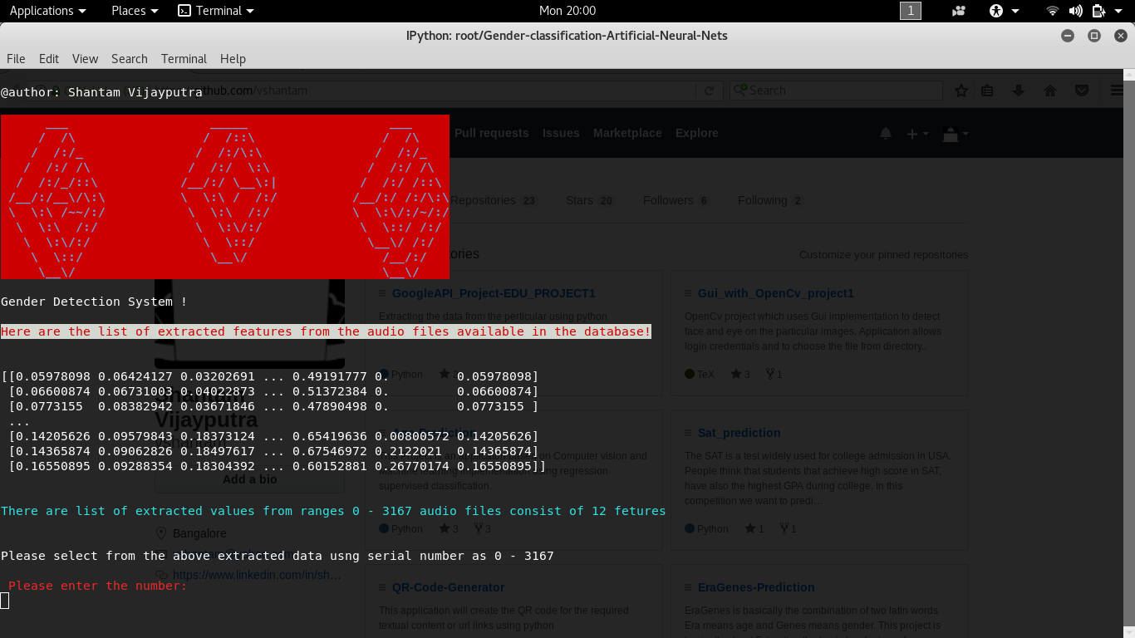  
Illustration 1: Main Interface

This interface displays pre extracted features in array format of the audio files exixt in the databases. To make the prediction all we have to do is to enter the number of array index the it will display the prediction.

The prediction will be compared with the actual label of the audio so that we can campare the result.

**Prediction snapshot:**

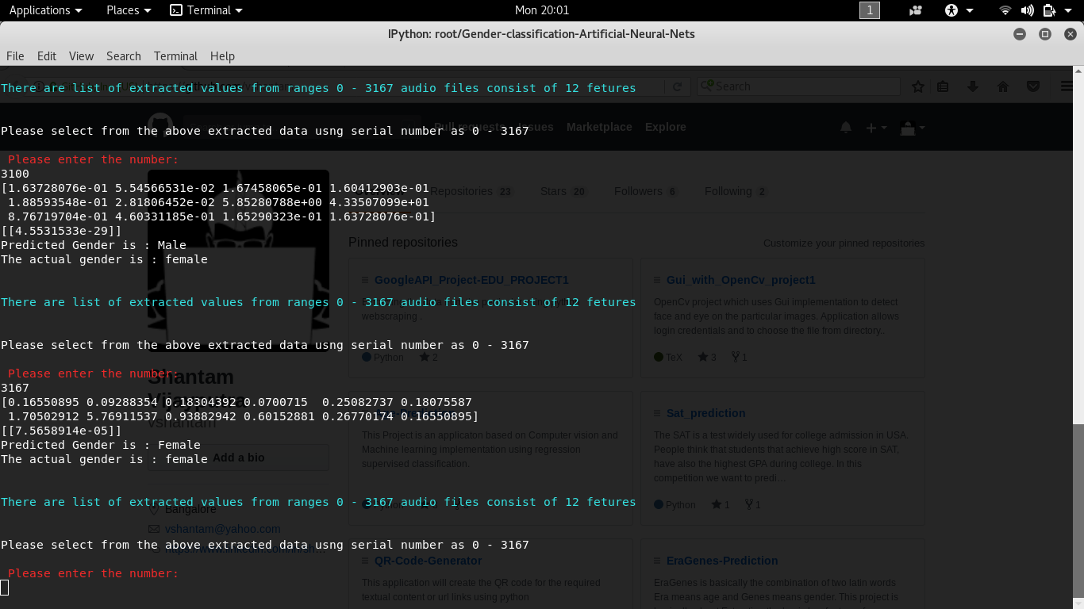  
Illustration 2: Correct prediction (female)

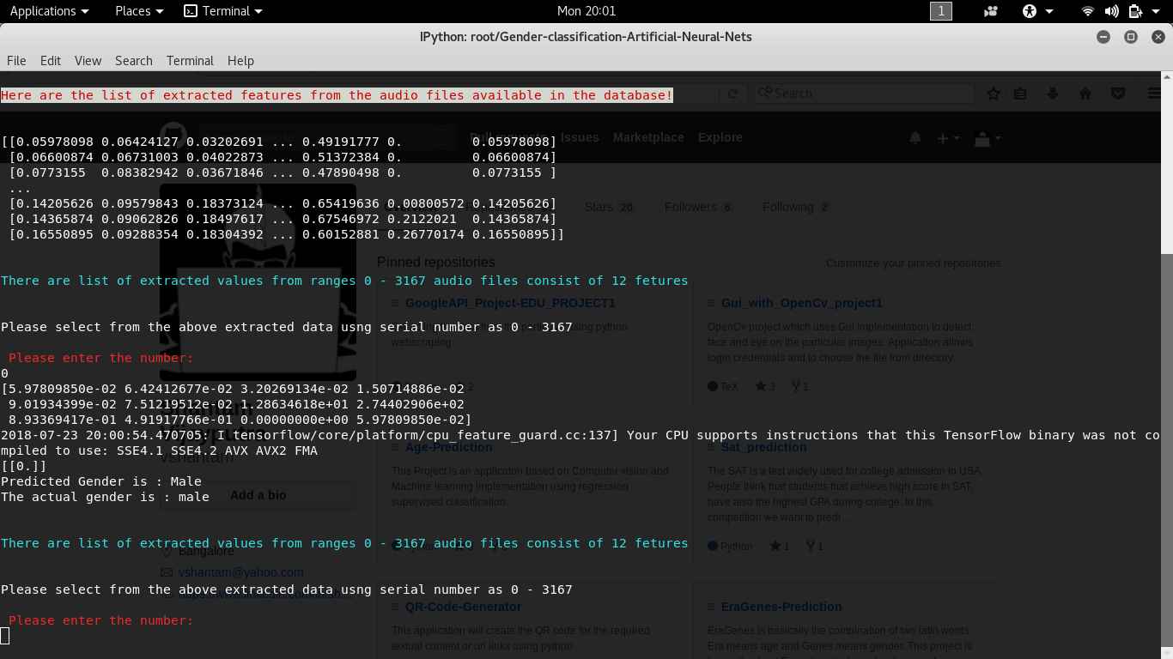  
Illustration 3: correct prediction (male)

we can see that above predicted value is same as actual label hence the prediction was accurate and correct.but some time we may not be able to get the correct predicton due to some bad feature or noisy value, which can be seen in the next snapshot.

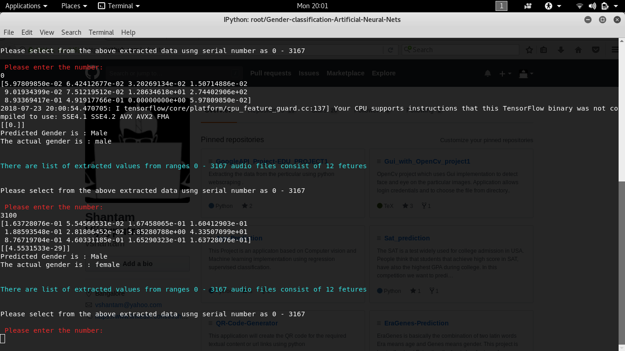  
Illustration 4: false prediction

Like in this snapshot we can see that the classifier predicted as “Male” but the actual label is “Female”.there are some reason which may causes the bad prediction value such as :

1.High Bias and High Variance.

2.Low Precision and Low Recall.